1. a) Create a socket program for Client-Server based chat application.

Code for server:

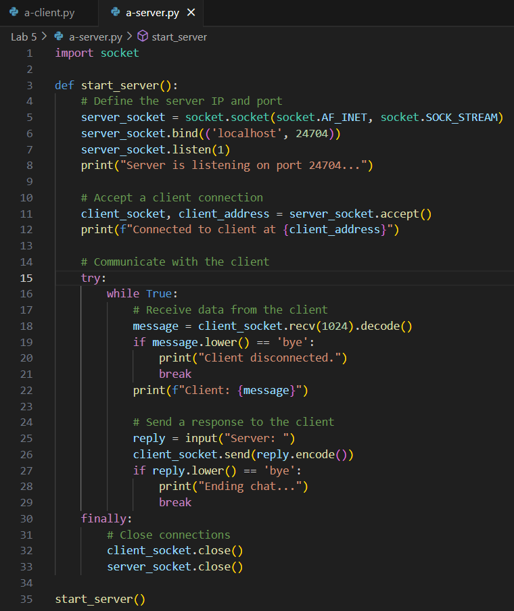

Code for client:

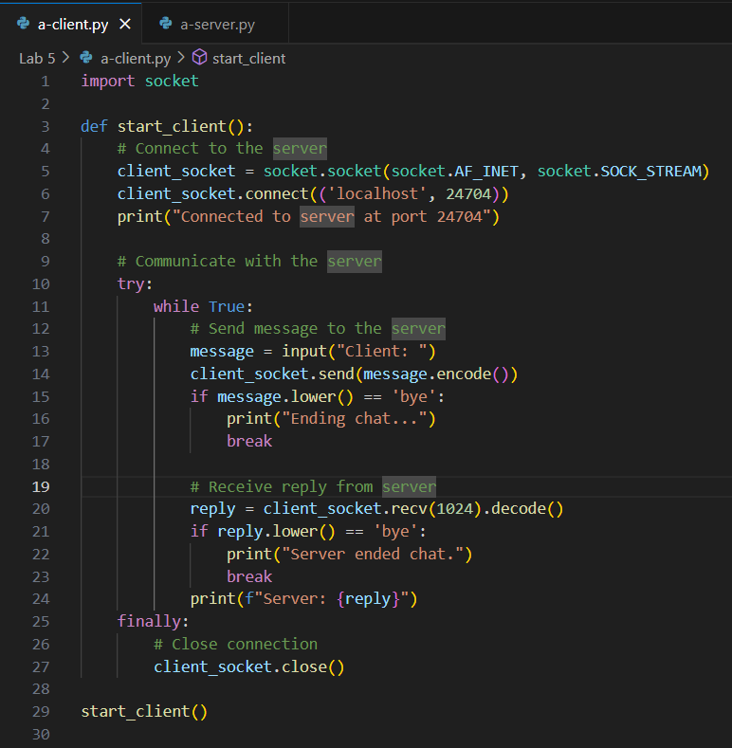

Output for server :

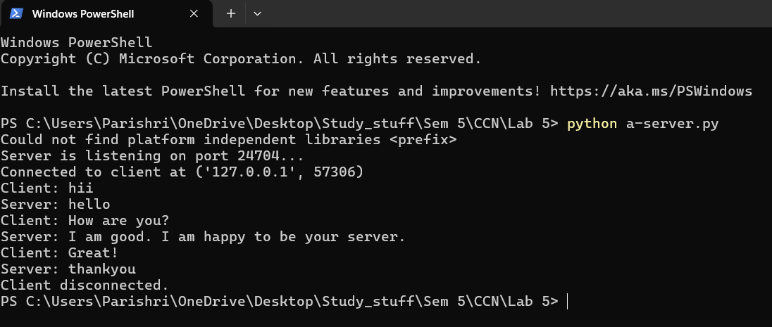

Output for client :

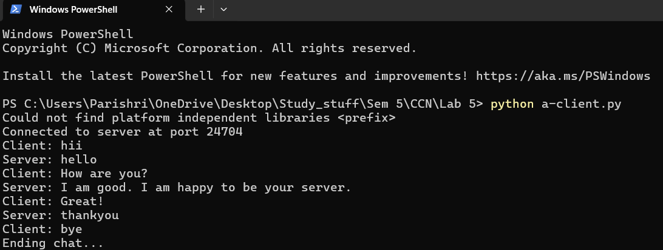

b) Create a file transfer socket based application with client-server connection.

Code for server:

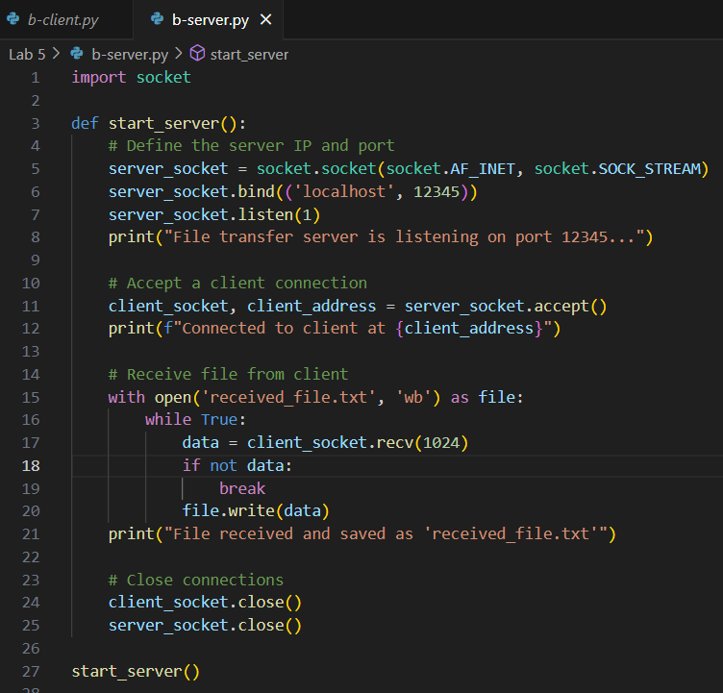

Code for client:

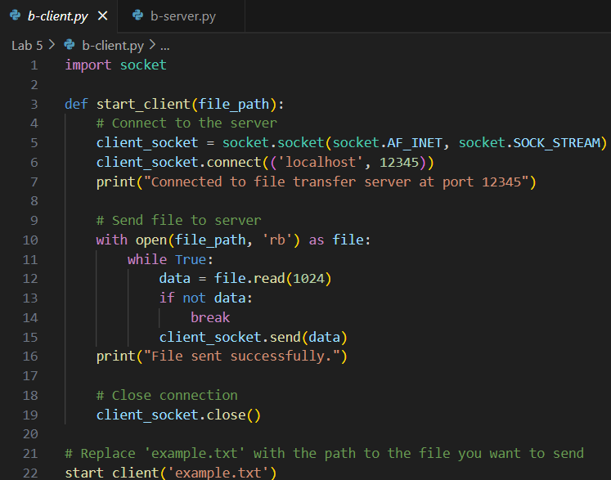

Example.txt - file to be transferred by client to server

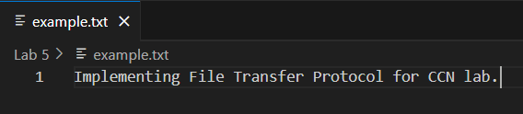

Output for server:

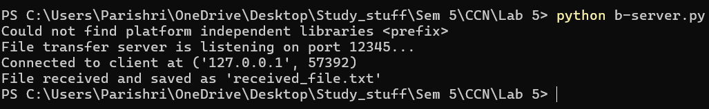

Output for client:



File received by server:

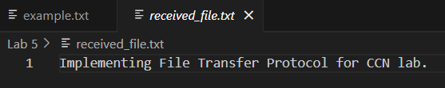

2. a) Develop a broadcasting application with Socket programming.

Code for server:

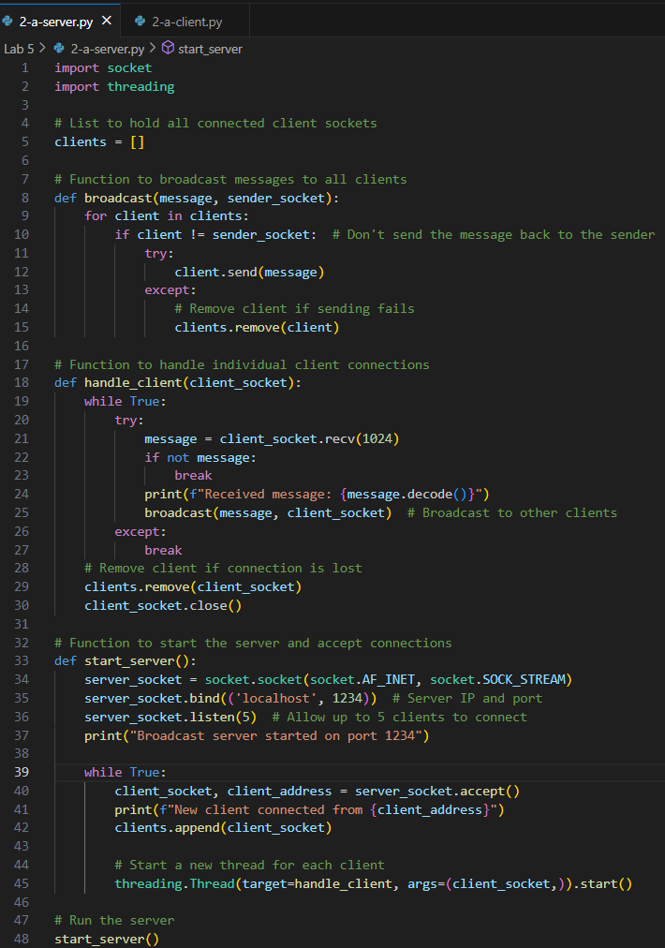

Code for client:

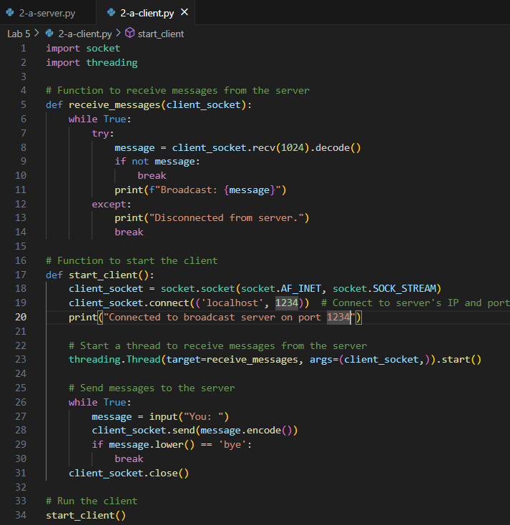

Output for server:

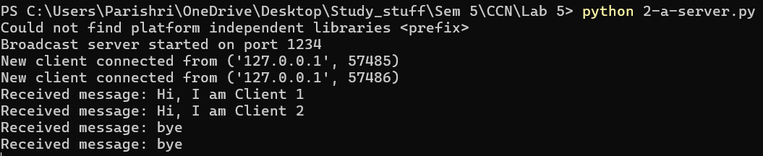

Output for client 1:

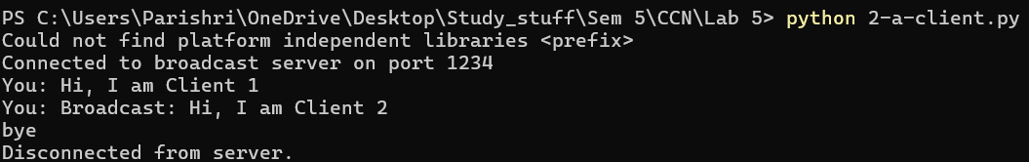

Output for client 2:

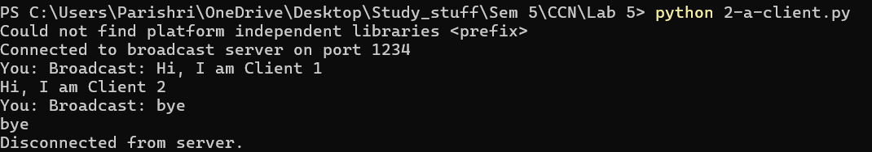

b) Form a data serves for data sharing within the group

Code for server:

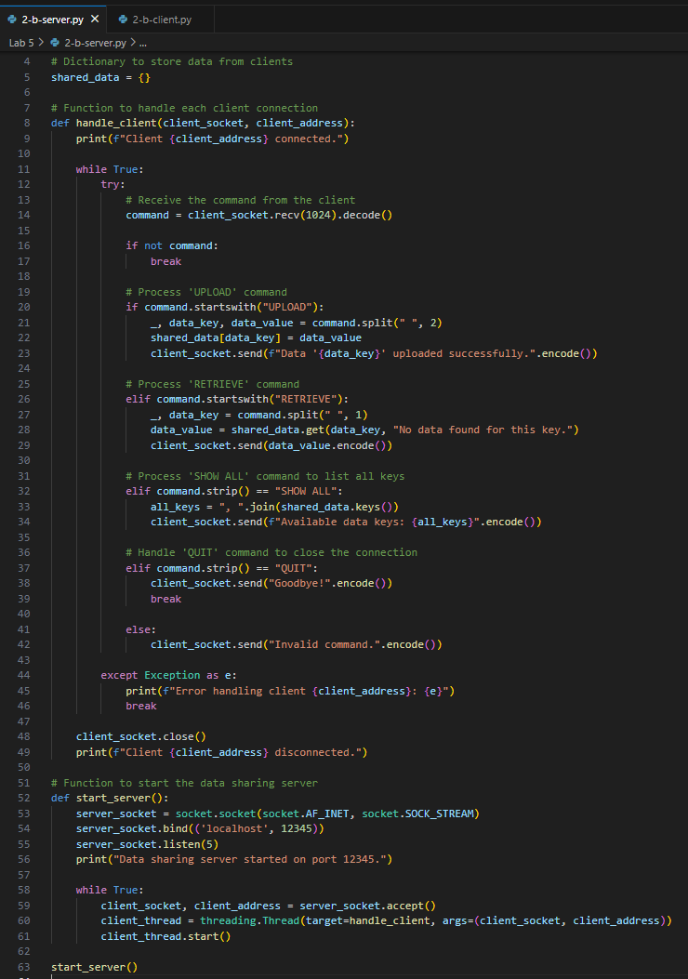

Code for client:

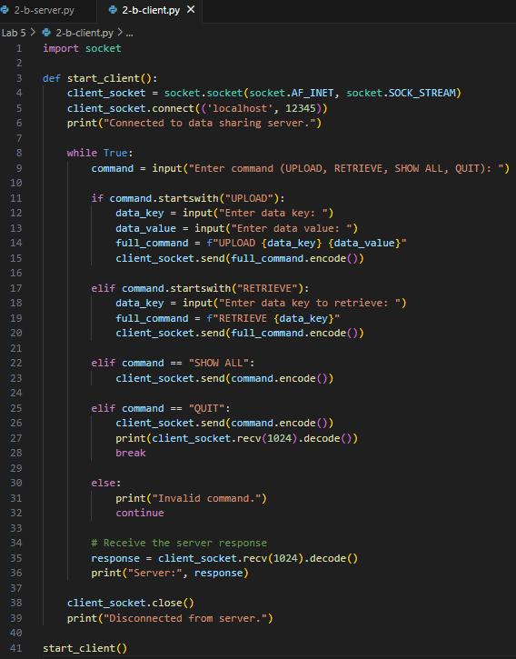

Output for server:

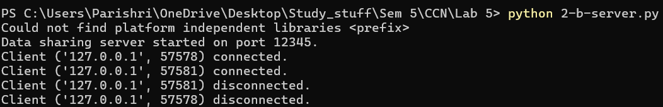

Output for client 1:

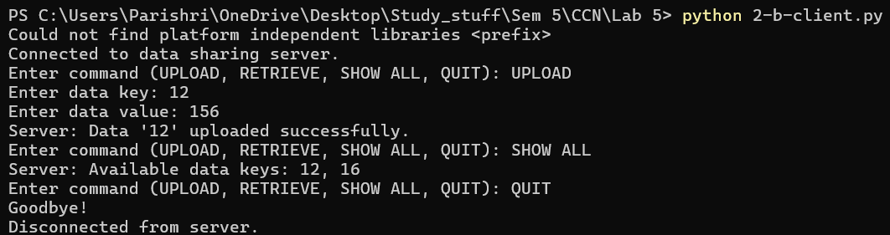

Output for client 2:

